**TABLE OF CONTENTS Page**

1. References 1

2. DEFINITIONS AND ACRONYMS 1

3. scope 1

4. PURPOSE 2

5. RISK ASSESSMENT 2

6. Required tools and equipment 3

7. experimental design / sample size justification 3

8. PROCEDURE 3

9. acceptance criteria 5

10. aTTACHMENTS 8

11. Revision History 8

# References

|  |  |
| --- | --- |
| MKT-CMR-029 | CMR Smoke Evacuation Product Line |
| MKT-CMR-023 | ACE Blade Product Portfolio |
| ENG-PS-007 | Smoke Evacuation and Accessories Product Spec |
| MKT-US-002 | Usability Specification – Smoke Evacuation Pencils and Universal ULPA Filter |
| ENG-PRT-121 | Ace Blade Clinical Trial Protocol |
| ENG-PRT-122 | Evaluation of Megadyne’s Ace Blade |
| ENG-RPT-196 | Test Report, ACE Blade Clinical Evaluation Report |

# DEFINITIONS AND ACRONYMS

N/A

# scope

This study includes the validation of the following ZIP-PENTM product codes and accessories.

|  |  |
| --- | --- |
| 252510 | ZIP-Pen Smoke Evacuation Pencil (10 ft Cord Length) and Holster |
| 252510EC | ZIP-Pen Smoke Evacuation Pencil (10 ft Cord Length), 22mm Connector and Holster |
| 252515 | ZIP-Pen Smoke Evacuation Pencil (15 ft Cord Length) and Holster |
| 252515EC | ZIP-Pen Smoke Evacuation Pencil (15 ft Cord Length), 22mm Connector and Holster |
| 252510BN | ZIP-Pen Bulk Nonsterile (10 ft Cord Length) and Holster |
| 252510ECBN | ZIP-Pen Bulk Nonsterile (10 ft Cord Length), 22mm Connector and Holster |
| ME7251C | ACE Blade 700, 2.5”, ZIP-Pen (10 ft Cord Length) |
| ME7251E | ACE Blade 700, 2.5”, ZIP-Pen (10 ft Cord Length), 22mm Connector |
| ME725M1C | ACE Blade 700, Modified 2.5”, ZIP-Pen (10 ft Cord Length) |
| ME725M1E | ACE Blade 700, Modified 2.5”, ZIP-Pen (10 ft Cord Length), 22mm Connector |
| 2330 | Filter, In-Line, ULPA, w/ regulator tubing set |
| 2560J | ZIP Pen Extension Nozzle 5.2 inch (13.2 cm) |
| 2540J | ZIP Pen Extension Nozzle 2.7 inch (6.8 cm) |

The scope of this study does not include validation of the ACE blade tissue effects. This was performed under protocol ENG-PRT-121, ENG-PRT-122 (1150433-10) with results documented in report ENG-RPT-196 (1150433-01).

A nurse representative may answer questions on behalf of both Scrub and Circulating nurse staff.

# PURPOSE

The purpose of this study is to provide objective evidence that the MEGADYNE ACE BLADE 700 Soft Tissue Dissector ZIP-PENTM Smoke Evacuation Pencil satisfies defined customer requirements when used within actual or simulated-use environments in a manner consistent with the Package Insert. This study will focus on the surgeon experience with the device. The ZIP-PENTM Smoke Evacuation Pencil (15 foot cord length) and 2330 Filter, In-Line, ULPA, w/ regulator tube set may also be evaluated permitted sufficient user availability.

# RISK ASSESSMENT

Any new risks identified will be assessed and added to the appropriate risk analysis document.

# Required tools and equipment

## ACE Blade 700, 2.5”. ZIP-Pen (10ft Cord Length), 22 mm Connector ME7251E

## ZIP-Pen 15’ with 22mm connector (252515)

## 2.5” EZ-CLEAN blade (0012, included with ZIP-Pen)

## In-Line ULPA Filter (2330)

## Suction Canister

## 22mm Male to 10mm Male connector (2145)

## Standard Suction tubing (2 ea)

## MegaPower generator (1000)

## Electrosurgical Patient Return Electrode (0855C or equivalent)

## Surgical Trainer

## Ex-vivo animal tissue

## A complete set of equipment used will be contained within the report if different from what is listed here.

# experimental design / sample size justification

This validation work is qualitative in nature. Statistical justification is not necessary given the nature of the study. There will be no statistical analysis of the study results. A small sample size will be used since the products being evaluated in the study or similar to products already on the market with a demonstrated performance record over the past 30 months.

# PROCEDURE

Each user will be provided with an IFU or copy of the IFU corresponding to the device they are validating prior to starting. The 2330 Filter will be attached between the suction canister and the wall suction by the Nurse representative per Figure 1. The Nurse representative will also connect the ACE BLADE 700 (smoke evacuation tube) to the suction canister per Figure 2. A 2151 Filter Connection Adaptor may also be needed if the ZIP-Pen (15 ft Cord Length) and Holster is used in the study. Both activities will occur prior to the surgeon evaluation.

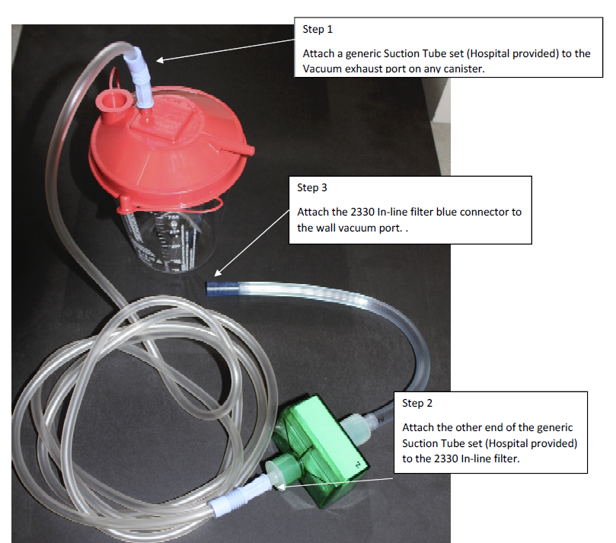

Figure 1

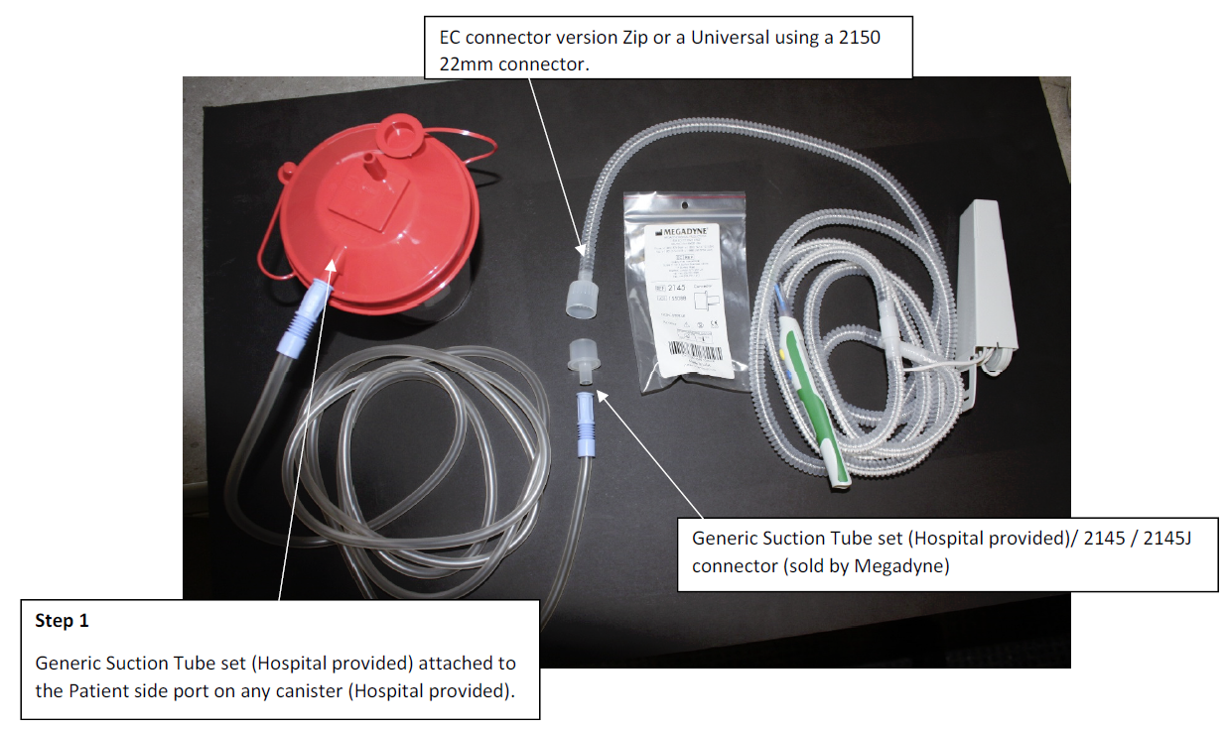

Figure 2

A Smoke Evacuator will not be used for the evaluation, as an in-line filter with standard surgical vacuum is considered worst case for smoke evacuation compared to a dedicated Smoke Evacuator. There will be an ECVV120 MiniVac Smoke Box on hand in case any issues arise with the wall suction.

The Surgeon evaluation will be performed on ex-vivo animal tissue (for example a steak or a roast which are good modesl for creating smoke) contained inside a surgical simulation trainer. See Figure 3. Living tissue is not required as hemostasis is not being assessed in this study. This trainer will simulate an open procedure where the Surgeon is using the device through the incision. A return electrode will be attached to the ex-vivo tissue inside the trainer.

|  |  |
| --- | --- |
|  |  |

Figure 3

The surgeon will be asked to use the cut and coagulate modes of the ZIP-PEN on the tissue and rate the performance per Section 9. The generator will be set to 30W for both cut and coag (as this is considered standard) and may be adjusted at the request of the surgeon. The surgeon will also be asked to clean the active electrode. The exact sequence of events for the evaluation is captured in Attachment 1.

Upon completion of the Surgeon evaluation, the Scrub Nurse or representative. The Circulating Nurse or representative will also be asked to disconnect the 2330 In-Line filter and ZIP-PEN from the wall suction and canister.

# acceptance criteria

Identify customer acceptance for each requirement listed in the tables below to be validated with the appropriate users. Table 1 requirements are to be evaluated by the surgeon as primary user. Table 2 requirements are to be evaluated by the scrub nurse or representative, but may be answered by the surgeon if the surgeon acknowledges that he/she also performs the tasks. Table 3 requirements are to be evaluated by the circulating nurse or representative.

**Table 1: Surgeon validated requirements**

|  |  |
| --- | --- |
| Requirement | Questionnaire |
| Must evacuate smoke away from the surgical site in an efficient and effective manner. | Rate the ability to evacuate smoke away from the surgical site |
| Must be able to visualize the tip during the procedure. | Rate the ability to visualize the active electrode during the procedure |
| Design of nozzle and device shall allow adequate visibility of surgical area | Rate the ability to visualize the active electrode during the procedure |
| Must be ergonomic and as minimally obtrusive to the surgical process/procedure | Rate the ability to visualize the active electrode during the procedure  Rate the ergonomics of the device |
| Tubing will swivel near the pencil connection as to minimize drag and maximize surgeon ergonomics. | Rate the ergonomics of the device  Rate the amount of drag on your hand from the tubing (zipped configuration) |
| Must have a tactile feel with button push | Rate the tactile feel of the buttons |

**Table 2: Scrub Nurse or Surgeon validated requirements**

|  |  |
| --- | --- |
| Requirement | Questionnaire |
| Active electrode must remain secure during cleaning of the tip | Rate the security of the active electrode when cleaning |
| Active electrode must be capable of being removed during the surgical procedure | Rate the ability to remove the active electrode |
| Nozzle to be designed so that the active electrode tip is easily insert able into the collet | Rate the ability to insert the active electrode |

**Table 3: Circulating Nurse or equivalent validated requirements**

|  |  |
| --- | --- |
| Requirement | Questionnaire |
| In-Line filter to connect from the wall suction tubing to the suction canister. Connection sizing on the filer to accommodate suction canister tubing. | Rate the ability to connect the In-Line filter to the wall and suction canister  Rate the ability to disconnect the In-Line filter to the wall and suction canister |
| Adapters will be developed/provided as necessary to ensure the connection of the MEGADYNE smoke evacuation pencil with a variety of manufacturer’s smoke boxes either via a universal connector size, by adapters or by removing the connector as necessary. | Rate the ability to connect the Zip-pen to the suction canister  Rate the ability to disconnect the Zip-pen to the suction canister |

The moderator will ask questions from the questionnaire with user answers recorded by an observer. Responses for all questions will be “Acceptable”, “Acceptable with Comments” or “Unacceptable”. In the event of responses of “Acceptable with Comments” or “Unacceptable”, the moderator shall ask specific clarifying follow up questions to the study participant in order to completely understand the logic behind their response and what aspect of the product or design caused the ranking response.

Response of “Acceptable” and “Acceptable with Comments” (where comment was acceptably clarified) will be considered responses that satisfy the acceptance criteria for this study.

Statistical methods will not be necessary for the interpretation of the data generated during this evaluation. Due to the design/nature of the study, statistical evaluation is not considered to be appropriate.

This study is intended to evaluate 3 separate product lines, and not all requirements apply to all products. Applicable requirements are listed in Table 4. Validation of the ACE BLADE 700 with surgeons will be completed first and pending availability of surgeons validation may or may not be conducted using the ZIP-Pen 15.

Deviations from this protocol will be documented in the final report. Relevant participant comments will be recorded for incorporation in the completion report.

**Table 4: Products and applicable requirements**

|  |  |  |  |  |
| --- | --- | --- | --- | --- |
|  | **Validation Question** | **2330 Filter** | **ACE 700** | **ZIP 15** |
| 1 | Rate the ability to connect the In-Line filter to the wall and suction canister | X |  |  |
| 2 | Rate the ability to connect the Zip-pen to the suction canister | X |  |  |
| 12 | Rate the ability to disconnect the In-Line filter to the wall and suction canister | X |  |  |
| 13 | Rate the ability to disconnect the Zip-pen to the suction canister | X |  |  |
| 3 | Did the device monopolar functionality perform as expected |  | X | X |
| 4 | Rate the ability to evacuate smoke away from the surgical site | X | X | X |
| 5 | Rate the ability to visualize the active electrode during the procedure |  | X | X |
| 6 | Rate the ergonomics of the device |  | X | X |
| 7 | Rate the amount of drag on your hand from the tubing |  | X | X |
| 8 | Rate the tactile feel of the buttons |  | X | X |
| 9 | Rate the security of the active electrode when cleaning |  | X | X |
| 10 | Rate the ability to remove the active electrode |  |  | X |
| 11 | Rate the ability to insert the active electrode into the collet |  |  | X |

Questions 1, 2, 4, 12 and 13 are required to validate product code 2330. Questions 3 – 9 are required to validate ACE 700 product codes ME7251C, ME7251E, ME725M1C, ME725M1E. Questions 3-11 are required to validate ZIP-PEN product codes 252510, 252510EC, 252515, 252515EC, 252510BN, 252510ECBN.

# aTTACHMENTS

Attachment 1 Discussion Guide

Attachment 2 2330 Filter Draft IFU

# Revision History

|  |  |  |  |
| --- | --- | --- | --- |
| **REVISION** | **DOCUMENT CHANGE ORDER NUMBER** | **DESCRIPTION OF CHANGE** | **EFFECTIVE DATE** |
| See Master Control for revision history. | | | |

